
AFRO HR
Enterprise System Solution Blueprint
File 01 — Business Context, Stakeholders, Personas & Organization
Operating Model & Responsibility Definition
Organization • Stakeholders • Personas • Process Ownership • RACI • Decision Rights
Prepared for | AFRO Group
Document ID | AFRO-HR-SSB-01
Version / Status | 1.0 / Draft for Review
Date | 10 August 2026

0. Document Control & Evidence Basis
This file defines who participates in AFRO HR, how the current People & Culture organization is represented, and how responsibility should be governed in the target system.

Document Control
Field | Value
Document Title | AFRO HR — Enterprise System Solution Blueprint — File 01
Document ID | AFRO-HR-SSB-01
Version | 1.0
Status | Draft for Review
Primary Audience | Executive Management, People & Culture, Process Owners, Solution Design, Security, PMO
Purpose | Define business context, stakeholders, personas, organizational representation, process ownership, responsibility model and validation decisions.
Language | English master working document; UI localization is addressed in later specifications.

Evidence Rule
Two current-state sources are treated as authoritative for this file: the People & Culture Department Structure 2026 and the People & Culture Operations Manual. The organization chart is the source for named People & Culture roles and reporting structure. The operations manual is the source for documented process participants, responsible teams, outputs, SLAs and policy controls.
Target-state marker. Stakeholder classifications, personas, RACI accountability assignments, access boundaries and governance mechanisms that are not explicitly stated in the source documents are presented as proposed system-design requirements and require client confirmation.

Approval / Review Roles
Review Role | Review Focus | Status
Executive Sponsor / CEO | Strategic authority, escalation path and executive information needs | Pending
People & Culture Manager | Organization, process ownership, service model and role definitions | Pending
Functional Process Owners | Detailed responsibilities, handoffs, service levels and data ownership | Pending
Technology / Security | Identity model, access segmentation, organization hierarchy and audit feasibility | Pending
PMO / Product Owner | Scope consistency, acceptance decisions and backlog traceability | Pending

0.1. Contents & Reading Guide
Section | Content
1 | Business Context & Operating Model
2 | Current People & Culture Organization
3 | Organization Design Implications for AFRO HR
4 | Stakeholder Ecosystem
5 | Stakeholder Influence & Dependency
6 | Persona Model & Segmentation
7 | Executive & P&C Leadership Personas
8 | People & Culture Specialist Personas
9 | Manager & Project Personas
10 | Employee & Field Workforce Personas
11 | Support / Control Function Personas
12 | Target Organization Data Model Requirements
13 | Process Ownership Model
14 | RACI — Recruitment & Onboarding
15 | RACI — Payroll, HR Operations & Offboarding
16 | Authority, Delegation & Access Principles
17 | Cross-Functional Handoffs & SLA Ownership
18 | Governance Forums & Decision Rights
19 | Open Decisions, Risks & Validation Checklist
Appendix | Source-to-Design Traceability

How to Review This File
- Confirm the source-derived organization and process participants before approving any target-state role mapping.
- Validate persona needs against real working practices, especially project-based and field workforce operations.
- Approve process ownership separately from system permissions; a process owner does not automatically receive unrestricted employee data.
- Treat RACI “A” assignments as proposed where the source only identifies a responsible team.
- Resolve open decisions before detailed RBAC, workflow and screen specifications are frozen.

1. Business Context & Operating Model

Current Operating Context
The current People & Culture operating model is structured around specialist functions that participate at different points in the employee lifecycle. The Operations Manual documents recruitment, onboarding, offboarding, payroll, allowances, KPI bonus management and ongoing HR Operations. These processes require repeated handoffs between People & Culture specialists, project/department managers and enabling functions such as HSE, IT, Administration, Finance and Legal.

Business Characteristics the System Must Support
- Permanent, temporary, project-based, white-collar and blue-collar employee populations are explicitly within the policy scope.
- Project code, project name, direct manager, work/site location, salary, allowances and benefits appear as operational data points during hiring and onboarding.
- Operational readiness is cross-functional: Personnel, Talent Acquisition, IT, Operations, Administration and HSE participate before deployment.
- Payroll requires validated master data, project allocation updates, deductions/adjustments and Finance payment execution.
- HR Operations acts as the primary People & Culture representative for assigned projects/accounts after onboarding and continues through workforce support and resignation coordination.
- Disciplinary cases require controlled cooperation among HR Operations, Direct Manager and Legal Affairs.

Target Operating Shift
Current Operating Pattern | Target AFRO HR Mechanism
Email / spreadsheet handoffs | Structured workflow tasks with owner, due date, status and evidence.
Role knowledge held by individuals | Configured process ownership, RACI and delegation records.
Project/account-based HR support | Scoped user populations by project, account, business unit and reporting line.
Cross-functional readiness follow-up | One employee readiness checklist with task ownership across functions.
Recurring payroll collection cycles | Cut-off calendar, controlled inputs, validation queue, lock and audit trail.
Manual compliance follow-up | Expiry alerts, eligibility rules, mandatory gates and exception escalation.
SOURCE BASIS Operations Manual Parts I–IV and HR Operations workflow; target mechanisms are proposed system design.

2. Current People & Culture Organization
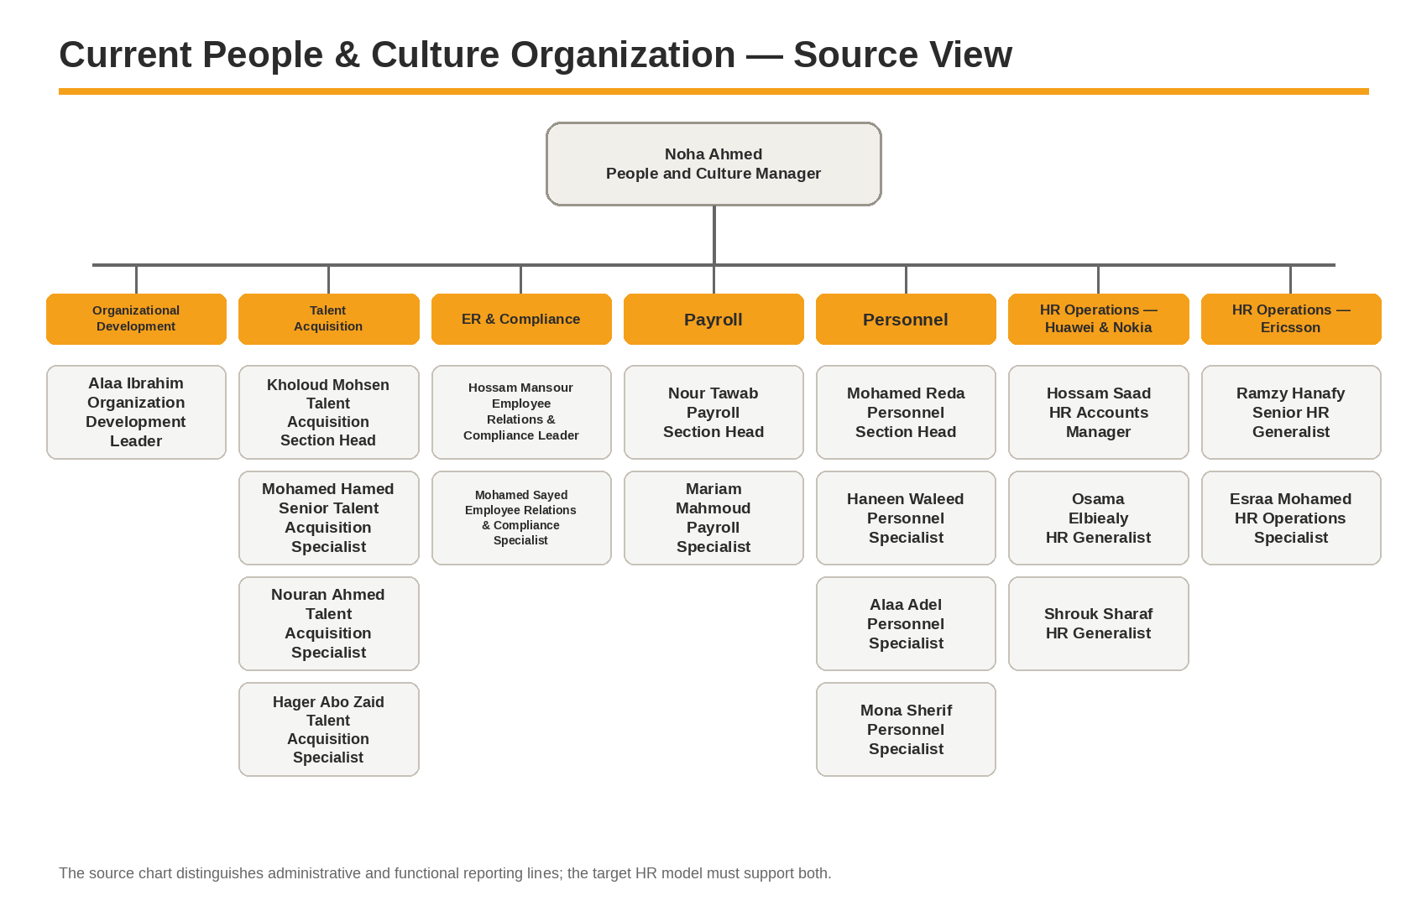
Source-derived structure. The 2026 organization chart places Noha Ahmed as People and Culture Manager and shows distinct Organizational Development, Talent Acquisition, ER & Compliance, Payroll, Personnel and two HR Operations account groupings. The chart also distinguishes administrative reporting from functional reporting.
SOURCE BASIS People and Culture Dept. Structure 2026 — single-page organization chart.

3. Organization Design Implications for AFRO HR

What the Current Structure Means for the System
Observed Operating Feature | System Design Implication
Multiple specialist functions | System roles must be function-specific; “HR User” is too broad for privacy and control.
Two HR Operations groupings by customer/account | Access needs to be scoped by account/project/customer population, not only department.
Administrative vs functional reporting | Employee assignment must support more than one reporting relationship without corrupting the primary line manager hierarchy.
Personnel and Payroll are separate functions | Employee master data ownership and payroll processing rights must be separated with controlled handoff.
ER & Compliance is distinct | Sensitive case records require restricted case-level visibility and confidentiality controls.
OD is a dedicated function | Organization structures, positions, job architecture and future org scenarios need controlled ownership separate from daily personnel transactions.
Project managers participate in HR workflows | Manager self-service must work across projects and allow multi-project responsibility where authorized.
HSE / IT / Finance / Legal are outside P&C but required | Cross-functional task users need minimum required data rather than full employee profiles.

Organization Representation Principle
Target-state design. AFRO HR should model Company → Business Unit → Department/Function → Position → Employee Assignment, while separately supporting Project/Account Assignment, Work Location/Site, Administrative Manager, Functional Manager and temporary acting/delegated authority. These relationships must be effective-dated.

Minimum Historical Requirement
Changes to manager, position, department, project/account, location or employment assignment should create dated history. Overwriting these values would make payroll allocation, approvals, audit and historical reporting unreliable.

4. Stakeholder Ecosystem
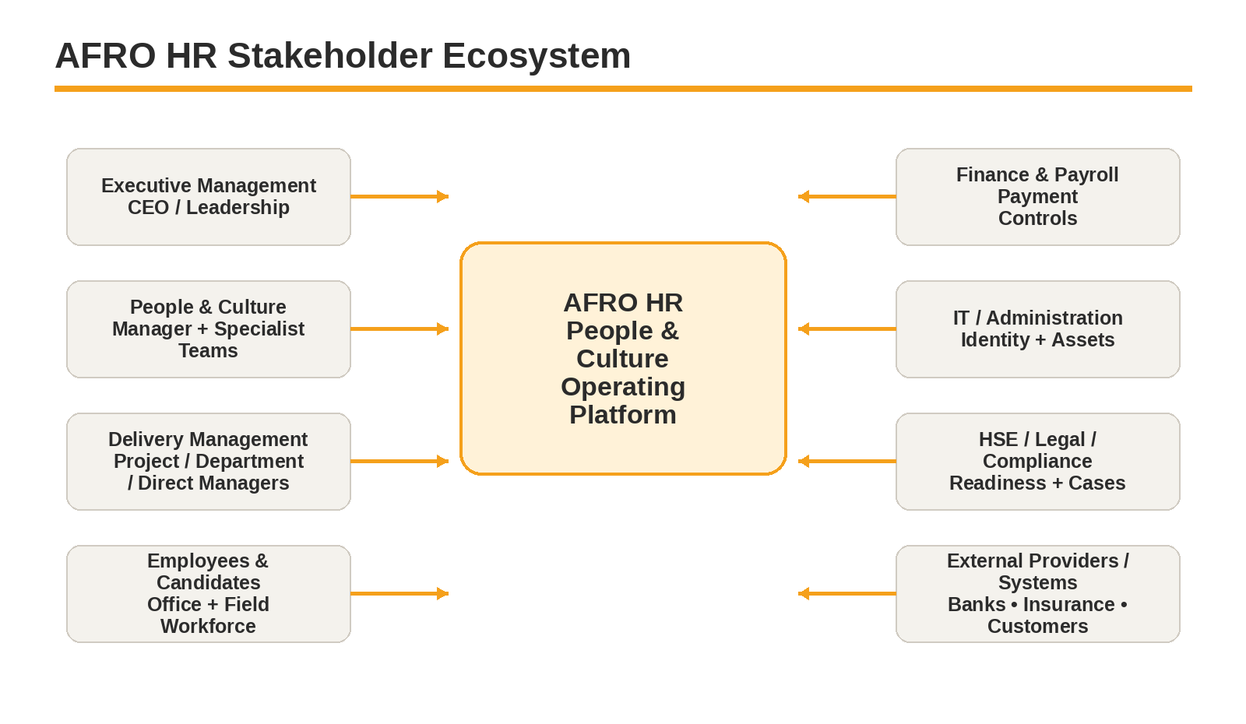

Stakeholder Groups and Primary Interest
Group | Primary Interest / Expected Outcome
Executive Management | Trusted headcount, people cost, workforce risk, organization decisions and exception visibility.
People & Culture Management | Controlled processes, policy compliance, service performance, capacity and auditability.
P&C Specialist Teams | Efficient queues, complete data, clear ownership, fewer duplicate entries and reliable handoffs.
Project / Department / Direct Managers | Fast staffing, team readiness, attendance/leave approvals, workforce visibility and performance actions.
Employees / Candidates | Clear status, self-service, timely decisions, correct pay, accessible documents and transparent requests.
Finance / IT / HSE / Legal / Administration | Only the HR tasks and data required to complete their control responsibilities.
External Providers / Systems | Defined interfaces, reconciliation and secure data exchange.

5. Stakeholder Influence & Operational Dependency
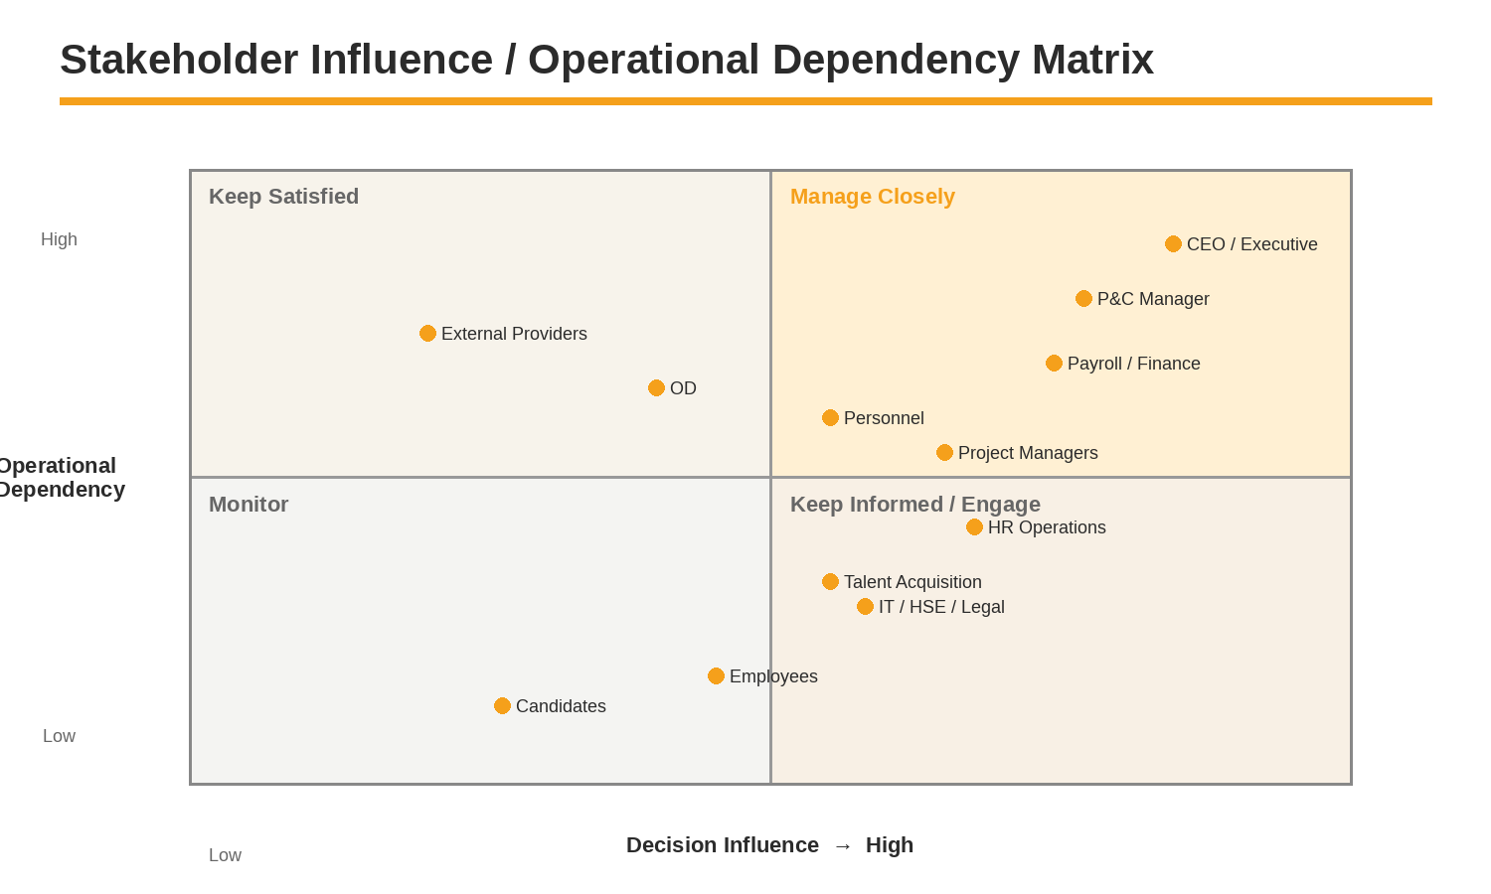
Interpretation. The matrix is a target-program stakeholder assessment, not a statement from the source documents. It is intended to guide workshops, approvals and change management. Exact positions should be validated with AFRO leadership.

Engagement Consequence
- CEO / Executive Management and the People & Culture Manager should approve scope, policy exceptions and high-impact decisions.
- Payroll and Finance require early design involvement because payroll cut-offs, payment controls and reconciliation cannot be treated as late-stage integration details.
- Project managers and HR Operations must be represented in workflow design because project/account assignment is a recurring operating dimension.
- Employees and field users need usability validation even when their formal decision influence is lower; poor adoption can invalidate attendance and self-service processes.

6. Persona Model & Segmentation

Why Personas Are Separate from Roles
A system role defines permissions. A persona describes goals, working context, decisions, frequency, devices, pain points and information needs. One person may carry several roles and still share one persona; conversely, two users with the same formal title may require different experiences because one supports office employees and the other supports field projects.

Persona Segments
Segment | Representative Personas | Experience Priority
Executive | CEO / Executive Sponsor | Decision visibility, exceptions, trend analysis, approvals.
P&C Leadership | People & Culture Manager; functional section/area heads | Workload, compliance, SLA, policy, capacity, approval oversight.
P&C Specialists | TA, Personnel, Payroll, HR Operations, ER & Compliance, OD | High-volume processing, data quality, cases, handoffs and audit.
Business Management | Project Manager, Department Manager, Direct Manager, Supervisor | Team actions, approvals, staffing, readiness, attendance, performance.
Employee / Candidate | Office employee, field technician, candidate | Simple mobile/self-service, status, evidence, documents and notifications.
Control Functions | Finance, IT, HSE, Legal, Administration | Task-based access, evidence, sign-off and reconciliation.
Platform Control | System Administrator, Security/Audit, Product/Process Admin | Configuration, access governance, traceability and safe change.

Common Persona Attributes to Capture
- Organization scope and project/account scope.
- Primary device: web, mobile or both.
- Transaction frequency and peak periods.
- Approval authority and delegation needs.
- Sensitive data categories required.
- Offline or field-connectivity constraints.
- Notifications and SLA expectations.
- AI functions permitted: search, explain, draft, recommend or execute with approval.

7. Executive & People & Culture Leadership Personas
CEO / Executive Sponsor  Enterprise decision maker | Goals: Understand workforce capacity, cost, risk and strategic organization issues without opening operational records.  Core transactions: Strategic approvals, organization decisions, high-risk exceptions, dashboard review.  Data boundary: Enterprise aggregates by default; drill-down only where approved and necessary.  Success signal: Consistent executive KPIs, fewer unresolved escalations, timely workforce decisions.  AI assist: Narrative summaries, anomaly explanations, scenario questions; no autonomous employment decisions.
Noha Ahmed  People and Culture Manager | Goals: Control the full P&C operating model, ensure policy compliance, balance workload and resolve escalations.  Core transactions: Approvals, SLA/escalation review, workforce analytics, policy/process ownership, exception decisions.  Data boundary: Broad P&C visibility with restricted treatment of highly confidential case/medical data based on need-to-know.  Success signal: Process SLA adherence, payroll/control accuracy, lower backlog, visible workforce risks.  AI assist: Daily operational brief, root-cause summaries, policy-aware recommendations, controlled approval preparation.
Functional Lead / Section Head  TA / Personnel / Payroll / ER / OD leadership persona | Goals: Manage team queue, quality, SLA and specialist outcomes within the function.  Core transactions: Work allocation, review, approvals, exception resolution, functional reporting.  Data boundary: Function + assigned population; cross-function data only where workflow requires.  Success signal: Backlog aging controlled, fewer rework cycles, measurable service performance.  AI assist: Queue prioritization, exception clustering, draft responses and quality checks.
Name usage. Noha Ahmed is explicitly named in the source organization chart. Other leadership personas are role templates; detailed authority levels require approval in the RBAC and workflow design.

8. People & Culture Specialist Personas
Talent Acquisition Specialist  Recruitment processor | Goals: Move approved demand through sourcing, screening, interviews, selection, offer and handover with complete records.  Core transactions: Candidate search/screening, shortlist, interview coordination, evaluations, offers, candidate communication.  Data boundary: Recruitment data plus approved requisition and compensation range; no general payroll access.  Success signal: Time-to-fill, SLA adherence, qualified shortlist quality, complete hiring file.  AI assist: CV summarization, match explanation, interview question drafts, communication drafts; human selection remains required.
Personnel Specialist  Employment record & compliance processor | Goals: Create and maintain legally complete employee records and control onboarding/offboarding documentation.  Core transactions: Documents, contracts, insurance, HR code, employee master updates, onboarding/offboarding records.  Data boundary: Personnel and compliance data for assigned population; salary fields only as required for employment/payroll handoff.  Success signal: Complete files, timely activation, low missing/expired documents, accurate employee master.  AI assist: Document checklist review, missing-item detection, letter/form drafting, expiry prioritization.
Payroll Specialist  Compensation processing persona | Goals: Process accurate, approved payroll and related payment inputs on time with reconciliation and traceability.  Core transactions: Payroll register, adjustments, deductions, project allocation, taxes/social insurance inputs, payment file, cost reports.  Data boundary: Compensation/payroll data; restricted from unrelated case/medical records.  Success signal: On-time payroll, minimal corrections, reconciled totals, clear exception trail.  AI assist: Variance explanation, anomaly detection, pre-run checks, payroll query assistance; no unsupervised payment release.
HR Operations / Generalist  Project/account workforce support | Goals: Keep employees operationally ready and resolve day-to-day HR issues for assigned projects/accounts.  Core transactions: Activation follow-up, deployment readiness, schedules/attendance/leave coordination, requests, resignation coordination.  Data boundary: Assigned project/account populations and necessary lifecycle data.  Success signal: Fast issue resolution, readiness completion, reduced missing follow-up, manager/employee service quality.  AI assist: Daily risk list, overdue follow-up summary, draft employee communications, case routing suggestions.

8.1. Specialist Personas — ER, Compliance & OD
ER & Compliance Specialist  Confidential case processor | Goals: Handle employee relations and disciplinary matters consistently, privately and with evidence.  Core transactions: Incident intake, investigation tasks, statements/evidence, decisions, appeal/closure, compliance follow-up.  Data boundary: Case-level need-to-know; separate from general HR visibility and hidden from unauthorized managers.  Success signal: Complete evidence trail, timely case handling, controlled decisions, reduced confidentiality risk.  AI assist: Case chronology summaries, evidence indexing, policy lookup, draft notices; final decision remains human/authorized.
Organization Development Specialist  Organization & capability design persona | Goals: Maintain job/organization structures and support organization effectiveness and development decisions.  Core transactions: Org structures, positions, job architecture, competency models, OD initiatives, analysis.  Data boundary: Organization-wide structural data; limited personal data unless required for workforce analysis.  Success signal: Current org model, controlled structural changes, clear job architecture, useful organization analytics.  AI assist: Span/layer analysis, role comparison, job description drafts, organization scenario analysis.
People & Culture Service / Admin Persona  Cross-process coordination persona | Goals: Track employee requests, documents and follow-up tasks without acquiring unnecessary specialist permissions.  Core transactions: Service requests, letters, notifications, task routing, follow-up, status communication.  Data boundary: Service case data and request-specific employee fields only.  Success signal: Request SLA, clear ownership, reduced email chasing, employee status visibility.  AI assist: Request categorization, response drafting, knowledge search, routing recommendation.

Separation-of-Duties Requirement
The personas above intentionally separate recruiting, personnel, payroll, employee relations and organization design. The system should not collapse them into a single privileged “HR Admin” profile. Elevated cross-functional access should be exceptional, approved, time-bounded where possible and fully audited.

9. Manager, Project & Supervisor Personas
Project Manager  Project workforce owner / requester | Goals: Obtain required manpower, see assigned workforce readiness and approve project-related people actions.  Core transactions: Manpower request, candidate review, project allocation, attendance/leave approvals, readiness confirmation, handover.  Data boundary: Employees assigned to managed projects; compensation visibility limited to approved business need.  Success signal: Faster staffing, accurate allocations, lower attendance exceptions, ready workforce.  AI assist: Project staffing summary, risk/absence alerts, pending approvals, workforce questions.
Department / Direct Manager  Line manager | Goals: Manage team capacity, leave, performance and employee lifecycle actions with clear status.  Core transactions: Hiring request, team approvals, performance input, transfer/promotion requests, handover and offboarding input.  Data boundary: Direct/indirect reporting population according to configured hierarchy and delegated authority.  Success signal: Timely approvals, accurate team data, reduced HR follow-up, reliable performance records.  AI assist: Team brief, pending actions, draft feedback, policy guidance.
Field Supervisor  Operational attendance / evidence approver | Goals: Confirm who worked, where and under which shift/project when field evidence requires supervisor validation.  Core transactions: Roster view, attendance confirmation, exception evidence, task/shift confirmation, escalation.  Data boundary: Assigned crew/site/shift only; no payroll totals or confidential HR data.  Success signal: Accurate attendance evidence, quick exception resolution, minimal retrospective corrections.  AI assist: Exception summary, missing-evidence prompts; no authority to change payroll rules.
Scope rule. Manager access must follow effective-dated responsibility, not static job title. A manager who changes projects or receives temporary delegation should gain/lose access automatically according to the assignment dates.

10. Employee, Field Workforce & Candidate Personas
Office Employee  Employee self-service user | Goals: Complete HR transactions without visiting HR or relying on email for routine services.  Core transactions: Profile updates, leave, requests, documents, payslips, letters, learning, acknowledgements, notifications.  Data boundary: Own data only, plus organizational information intended for employees.  Success signal: High self-service completion, fewer manual requests, clear status and correct records.  AI assist: Policy Q&A, request guidance, payslip explanation within permitted limits.
Field Technician  Mobile-first field employee | Goals: Record attendance/evidence reliably, understand assignment/readiness and complete simple requests in low-friction mobile flows.  Core transactions: GPS/mobile attendance, roster/shift view, project/site assignment, evidence upload, leave/request, training/certification alerts.  Data boundary: Own data, assigned project/site/shift information, required policies and readiness status.  Success signal: High evidence completeness, fewer attendance disputes, timely readiness renewals.  AI assist: Simple multilingual guidance, missing-step prompts, policy explanation; offline behavior to be confirmed.
Candidate  External pre-hire user | Goals: Apply, understand status, attend interviews and complete pre-joining requirements securely.  Core transactions: Application/profile, interview scheduling, document submission, offer review/acceptance, joining details.  Data boundary: Own candidate record only.  Success signal: Lower candidate drop-off, complete pre-joining data, timely acceptance and joining.  AI assist: Application guidance, status explanation, document checklist assistance.

Experience Constraints to Validate
- Arabic RTL, English and French experience expectations for each user group.
- Mobile connectivity and offline capture requirements for field sites.
- Identity method before HR Code exists for candidates/new joiners.
- Accessibility and device ownership policy for blue-collar / project-based populations.

11. Support, Control & Platform Personas
Persona | Required Actions | Minimum Data Boundary
Finance | Review approved payroll/allowance/KPI funding package, execute transfers, reconcile payment status, receive cost reports. | Payment totals, bank/payment fields and approved finance outputs; not full HR record.
IT / Identity Admin | Create/deactivate email and system access, provision approved access, recover IT assets. | Identity attributes, joining/leaving dates, required access profile and assigned assets.
HSE | Medical/HSE requirement tasks, safety training/certification readiness, clearance input. | Role/site/readiness requirements and relevant HSE/fitness status; medical detail tightly restricted.
Administration / Asset Custodian | Issue/recover ID cards, uniforms, phones and other assets. | Employee identity, location/project and assigned asset task.
Legal Affairs | Advise disciplinary/investigation processes and legal closure where required. | Specific case and relevant employment records on need-to-know basis.
System Administrator | Configure tenant/company, workflows, templates, reference data and technical settings. | Configuration access should not imply ability to read sensitive employee data.
Security / Auditor | Review access, audit trail, control evidence and segregation-of-duties exceptions. | Audit metadata and authorized evidence; controlled access to record content.
Least-privilege rule. Cross-functional users should normally receive task-centric access: enough data to execute the assigned step, but not a general employee profile. This reduces unnecessary exposure of compensation, disciplinary, medical and personal data.

12. Target Organization Data Model Requirements

Core Organization Objects
Object | Purpose / Key Relationships
Tenant / Company | Legal or operational company boundary; root for configuration, users, policies and data segregation.
Business Unit / Function / Department | Formal organizational hierarchy and cost/ownership reporting.
Position | Approved role slot in the organization; linked to job, grade, department and reporting position.
Job / Job Family / Grade | Reusable job architecture independent from a specific employee.
Employee Assignment | Effective-dated employment placement linking employee to position, manager, organization, location and employment attributes.
Project / Account Assignment | Effective-dated operational assignment that can differ from home department and may drive HR Operations support, attendance, allowances and cost allocation.
Work Location / Site | Office/site/geographic context used for attendance, deployment, allowances and compliance.
Reporting Relationship | Administrative manager, functional manager, dotted-line or temporary reporting relationship.
Delegation / Acting Assignment | Temporary authority to approve or act for another role/person with start/end date and scope.

Required Organization Controls
- No overlapping primary employee assignments unless an approved business rule explicitly allows it.
- Manager hierarchy must be cycle-safe and effective-dated.
- Project/account assignment must not silently change legal employer or home department.
- Historical approvals must remain attributable to the authority that existed at the transaction date.
- Organization changes should be future-effective and impact-assessed before activation.

13. Process Ownership Model
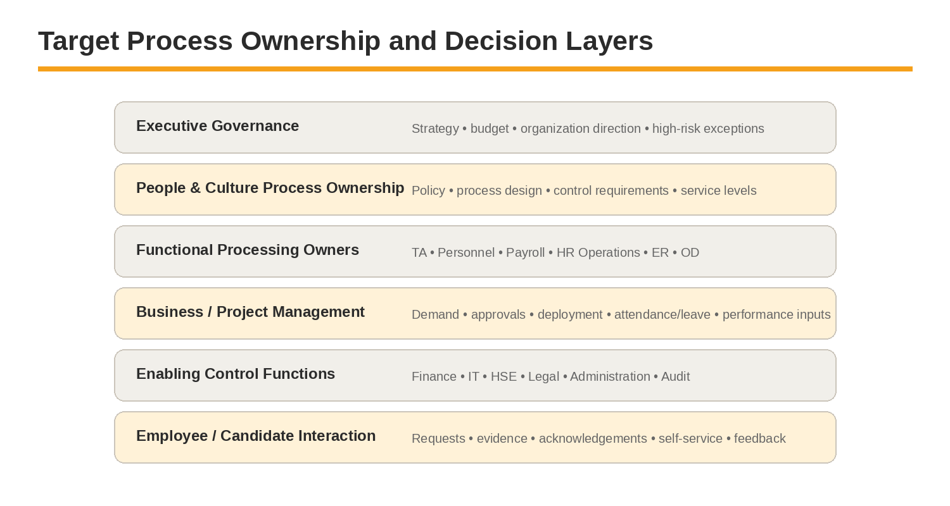

Source-Derived Responsible Teams
Process Area | Documented Responsible / Participating Teams
Hiring | Requester; Talent Acquisition; Technical; HSE as applicable.
Onboarding | Talent Acquisition; Personnel; IT; Operations; Administration; HSE; HR.
Payroll | Personnel; Payroll; Project Managers; Finance.
Allowances | Payroll; Finance; project inputs.
KPI Bonus | PMO; Payroll; Finance.
HR Operations | Personnel; HR Operations; IT; Administration; Operations; HSE; Direct Manager; Legal.
Offboarding | Personnel; IT; Employee; Direct Manager; Operations/HR/Admin; Finance; HR.
Process owner vs responsible team. The manual often identifies a “Responsible Team” for a stage, but does not consistently define one end-to-end accountable process owner. The target system should add explicit process ownership so policy, KPIs, changes and exceptions have one accountable business authority.

14. RACI — Recruitment & Onboarding
R = source-defined or primary operating responsibility; A = proposed target accountable owner where not explicitly stated; C/I = recommended from documented handoffs. Final approval is required.
Activity | P&C Mgr | TA | Personnel | Requester / PM | Technical | HSE | IT / Admin | Finance
Manpower request | I | C | I | R/A | C | I | I | C
Sourcing & screening | I | R/A | I | C | I | I | I | I
Requester shortlist review | I | C | I | R/A | C | I | I | I
Assessment & interviews | I | R | I | C | R | R* | I | I
Final candidate selection | A | R | I | R | C | C* | I | C
Job offer preparation / issue | I | R/A | I | C | I | I | I | C
Offer acceptance / joining confirmation | I | R | I | I | I | I | I | I
Onboarding initiation / hiring notification | I | R | R/A | C | I | C | C | I
Documents & personnel file | I | C | R/A | I | I | C | I | I
Contract / insurance / payroll registration | I | C | R/A | I | I | I | I | C
System / equipment readiness | I | C | R | C | I | C | R/A | I
HSE / medical readiness | I | I | C | C | I | R/A | I | I
Orientation / induction | I | C | C | C | I | R | R | I
Employment activation | A | C | R | C | I | C | C | I
RACI interpretation. “R/A” means the proposed accountable owner is also the primary processor. “R* / C*” means role participation is conditional, such as HSE involvement for safety-sensitive roles. The source manual should prevail for current responsibility until the target RACI is formally approved.

15. RACI — Payroll, HR Operations & Offboarding
Activity | P&C Mgr | Personnel | Payroll | HR Ops | PM / Direct Mgr | Finance | IT / Admin | ER / Legal
New hire payroll submission | I | R/A | C | I | I | I | I | I
Payroll master validation / register | I | C | R/A | I | I | I | I | I
Project allocation updates | I | I | R | C | R/A | I | I | I
Deductions / adjustments | I | C | R/A | C | C | C | I | I
Payroll processing / reports | I | I | R/A | I | I | C | I | I
Salary payment | I | I | C | I | I | R/A | I | I
Workforce management | I | C | I | R | R/A | I | I | C
Employee relations support | A | C | I | R | C | I | I | R/C
Investigation / disciplinary | A | I | I | R | R | I | I | R
Offboarding initiation | I | R/A | I | C | C | I | I | C
Access deactivation | I | R | I | C | I | I | R/A | I
Knowledge / task handover | I | I | I | C | R/A | I | I | I
Clearance / asset return | I | R | I | C | R | R | R | I
Final settlement / legal closure | A | R | R | C | C | R | I | C
Record closure / archiving | I | R/A | C | C | I | I | I | I
Control issue to resolve. The manual describes Finance as payment executor and Payroll as payroll processor, which supports segregation of duties. Final settlement accountability and approval thresholds should be explicitly confirmed before workflow build.

16. Authority, Delegation & Access Principles

Decision Authority Model
Principle | Target Requirement
Authority is contextual | Approval authority may depend on company, project, transaction type, amount/grade, employee population and employment action.
Delegation is explicit | Temporary delegation requires delegator, delegate, scope, reason, start/end dates and audit.
No self-approval by default | A user should not approve their own request or a transaction they prepared where SoD requires independent review.
Escalation is not silent approval | SLA escalation should notify/reassign according to policy; it must not auto-approve sensitive HR or payroll actions unless explicitly authorized.
Historical authority is preserved | A later org change must not rewrite who was authorized at the time an earlier transaction was approved.
Break-glass access is controlled | Emergency elevated access requires reason, time limit, enhanced logging and post-use review.

Access Dimensions
- Tenant / company.
- Function or role.
- Department / business unit.
- Project / account / customer.
- Reporting hierarchy.
- Location / site / shift or crew.
- Employee population (white-collar, blue-collar, temporary/project-based, etc.) where policy requires.
- Data sensitivity: compensation, medical/HSE fitness, disciplinary/case, personal identity, bank details.
- Transaction state: draft, submitted, approved, locked, paid, closed.
Security design handoff. This file defines the business need for scoped access. The detailed RBAC/ABAC model, privileged access, access reviews and segregation-of-duties rules belong to the later Security & IAM specification.

17. Cross-Functional Handoffs & SLA Ownership

Critical Handoffs
Handoff | Producer → Consumer | Control / Evidence Required
Approved hiring demand | Requester → Talent Acquisition | Approved requisition with position, vacancy count, project, manager, location, range, priority and type.
Selected candidate / hiring file | Talent Acquisition → Personnel | Approved selection, offer, joining date and supporting recruitment documents.
Onboarding tasks | Personnel / TA → IT, HSE, Operations, Administration | Assigned task, due date, required data, completion evidence and blocker reason.
Activated employee | Personnel → HR Operations / Project | Activation status, project assignment, manager, location and readiness state.
Payroll master updates | Personnel → Payroll | Approved employee changes effective for payroll period with source transaction reference.
Project allocation | Project Manager → Payroll | Effective-dated allocation change with approval and cut-off compliance.
Payment package | Payroll → Finance | Approved payroll/allowance/KPI payment file, control totals and authorization status.
Investigation input | HR Operations / Manager → ER / Legal | Case reference, allegation, statements/evidence, confidentiality classification and due dates.
Offboarding clearance | Personnel → IT / Admin / Finance / Manager | Clearance tasks, last working day, assets/liabilities and completion evidence.

SLA Ownership Pattern
Each workflow stage should store the SLA owner, start event, due rule, pause conditions, escalation path and completion evidence. The manual contains stage-specific SLAs and monthly payroll timelines; the system must convert those into configured timers rather than static document text.
Data-quality gate. A handoff should not be considered complete when an email is sent. Completion means the required structured data, approvals and evidence have passed validation and the receiving role can continue without re-keying or chasing missing information.

18. Governance Forums & Decision Rights
Forum / Owner | Core Decisions | Suggested Cadence
Executive Steering | Program priorities, budget, major policy decisions, high-risk exceptions, release approval. | Monthly / milestone
People & Culture Design Authority | Process ownership, policy interpretation, cross-function conflicts, service model, workflow approval. | Weekly during design; monthly after go-live
Payroll Control Review | Cut-off readiness, payroll exceptions, reconciliation, payment approval status and post-run issues. | Monthly payroll cycle
Data Governance | Employee/org/project master ownership, data definitions, quality issues, migration/reconciliation. | Biweekly / monthly
Security & Privacy Review | Role model, sensitive access, SoD conflicts, access review findings, privacy and AI permissions. | Monthly / release
Release / Change Control | Configuration changes, workflow/policy versions, UAT evidence and production release decision. | Per release
Operational Service Review | SLA, backlog, incidents, employee requests, integration failures and adoption metrics. | Weekly operational / monthly management

Decision Record Requirement
- Every material design decision should have an owner, date, rationale, impacted modules and effective version.
- Policy/configuration decisions should be traceable to the approving authority, not only a meeting note.
- Changes affecting payroll, employment status, security or compliance should require impact assessment and controlled deployment.
- Unresolved decisions should remain visible in a decision log rather than being embedded as hidden assumptions in development tickets.

19. Open Decisions, Risks & Validation Checklist

Priority Open Decisions
ID | Decision | Priority
O-01 | Confirm formal end-to-end process owner for Recruitment, Onboarding, Payroll, HR Operations and Offboarding. | High
O-02 | Confirm whether HR Operations scope is maintained by customer/account, project, geographic area or another assignment rule. | High
O-03 | Approve administrative vs functional manager definitions and which transactions each can approve. | High
O-04 | Approve monetary/grade thresholds and final authorities for hiring, salary change, promotion, termination and settlement. | High
O-05 | Confirm project manager access to salary/compensation information. | High
O-06 | Define data owner for employee master, project assignment, work location and cost allocation. | High
O-07 | Confirm identity model for candidates, employees and external/cross-functional users. | Medium
O-08 | Confirm field supervisor authority for attendance evidence and correction. | High
O-09 | Confirm confidentiality model for ER cases, medical fitness and bank data. | High
O-10 | Confirm delegation, acting assignment and absence-cover rules. | Medium
O-11 | Validate all current SLAs and payroll calendar dates before configuration. | High
O-12 | Approve which personas receive AI assistance and what action level is permitted. | Medium

Validation Checklist
- Named organization structure verified against the latest approved org chart.
- All process participants verified against actual operating practice, not only the manual.
- RACI accountable owners approved.
- Project/account scope model approved.
- Manager hierarchy and functional reporting rules approved.
- Sensitive-data boundaries approved by P&C and Security/Privacy.
- Delegation and approval thresholds approved.
- Persona/device/language assumptions validated through representative user interviews.

Appendix. Source-to-Design Traceability

Source References Used
Source | Used For
People and Culture Dept. Structure 2026 | Named P&C roles, functional branches, account-oriented HR Operations structure, administrative vs functional reporting distinction.
People & Culture Operations Manual — Part I Hiring | Requester, TA, Technical, HSE participants; hiring stages, outputs and SLAs.
Operations Manual — Part II Onboarding | TA, Personnel, IT, Operations, Administration, HSE and HR responsibilities; employee data and readiness requirements.
Operations Manual — Part III Offboarding | Personnel, IT, Direct Manager, Finance and other clearance participants; deactivation, handover, settlement and closure.
Operations Manual — Part IV Payroll / Allowances / KPI | Personnel, Payroll, Project Managers, Finance and PMO roles; monthly/quarterly handoffs and payment responsibilities.
Operations Manual — HR Operations | Project/account support, workforce management, employee relations, investigations, compliance follow-up and resignation coordination.

Target-State Design Items Introduced in This File
- Persona segmentation and experience priorities.
- Stakeholder influence/dependency assessment.
- Formal process-owner model distinct from stage responsibility.
- Proposed RACI accountability, consultation and information assignments.
- Organization object model: position, assignment, project/account assignment, reporting relationship and delegation.
- Access-scoping principles and sensitive-data segmentation.
- Governance forums, decision records and change-control expectations.
Traceability rule. Later functional, data, security and workflow specifications should reference these stakeholder/persona/process-owner identifiers so requirements can be traced back to a real actor and accountable business owner.

Next Blueprint File
File 02 — Enterprise System Map, Module Architecture & End-to-End Employee Lifecycle will convert the approved stakeholder and organization model into the functional map of the platform, showing the 20 modules, shared engines, cross-module dependencies, lifecycle events and system boundaries in greater detail.

